**ASSIGNMENT – 4**

1. Define presentation software. What are the features of presentation software?

Ans: Presentation software (sometimes called "presentation graphics") is a category of [application](https://www.techtarget.com/searchsoftwarequality/definition/application) program used to create sequences of words and pictures that tell a story or help support a speech or public presentation of information.

Features of presentation Software are as follows:

***1. Limited Customization and Standard Templates***

You can choose the colors, text sizes, and fonts, but your ability to design new content tends to be limited to what the software already has available. Using templates, slides will appear with text boxes for headings, images, and other suggested content. Although you have the option to choose a theme, the ability to change things up is minimal.

***2. Linear Flow***

In traditional presentation software, slides show up in a specific way: one at a time, in a fixed order. The flow is predetermined.

***3. Features for the Speaker, Not the Audience***

Most presentation software is designed to aid a presenter rather than to guide an audience through a content experience.

***4. Shareability at a Cost***

You will also have a channel of some kind for sharing your presentation with your audience. For example, cloud-based access allows you to display your slides from just about anywhere with an internet connection. But content is unlikely to be displayed in a way that changes based on what kind of device a person is using to view it.

***5. No Analytics***

Gathering information about how your audience is engaging with your content is difficult at best. Traditional presentation software leaves you in the dark about what your audience cares the most about. And without those analytic tools, it’s nearly impossible to iterate and improve your presentation.

**5 Uncommon Features of Presentation Software**

With Tiled, you can share your content experiences across multiple platforms, adapted to different devices, and receive actionable insights from real-time analytics. Unlike standard presentations, [**interactive slides**](https://www.tiled.co/product/platform) improve engagement, retention, and interaction — both with the content and your brand. Your presentation is no longer a slideshow. Now it’s an interactive presentation — a microapp!

1. What are the necessary points to be considered for good presentation?

Ans: 6 steps to a successful presentation:

* + Prepare carefully
  + Use visuals wisely
  + Consider your audience.
  + Practice with a friend.
  + Be positive.
  + Don’t rely on technology.

1. What is the difference between transition and animation? Discuss the process of adding transition and animation in MS PowerPoint.

Ans:

|  |  |
| --- | --- |
| **Animation in Digital Presentation** | **Transition in Digital Presentation** |
| It refers to the movement of presentation elements like text, images, charts, and more along either slide direction. | The typical movements that occur when you navigate from one slide to the next in a slide show are known as transitions. |
| ***Animations give the appearance of movement or continuous change.*** | ***A Transition effect causes a change from one slide to the next.*** |
| Use animation to provide feedback, highlight a connection, draw attention to a change, or visually delineate a task. | It adds to the presentation’s appeal. |
| It can also be used to predict how an activity will turn out. | The visual impact that occurs when you shift from one slide to the next during a presentation is known as transition. |

Slide transitions are the animation-like effects that happen when you move from one slide to the next during a presentation. Add slide transitions to bring your PowerPoint presentation to life.

1. Select the slide you want to add a transition to.
2. Select the **Transitions** tab and choose a transition.

Select a transition to see a preview.

1. Select **Effect Options** to choose the direction and nature of the transition.

**Note:**Not every transition has **Effect Options**.

1. Select **Preview** to see what the transition looks like.

To remove a transition, select **Transitions** > **None**.

1. What is Master slide? What are the available views in MS PowerPoint?

Ans:A slide master is the top slide in a hierarchy of slides that stores information about the theme and slide layouts of a presentation, including the background, color, fonts, effects, placeholder sizes, and positioning.

### Views for creating your presentation

#### Normal view

You can get to **Normal** view from the task bar  at the bottom of the slide window, or from the **View** tab on the ribbon.

**Normal** view is the editing mode where you’ll work most frequently to create your slides. Below, **Normal** view displays slide thumbnails on the left, a large window showing the current slide, and a section below the current slide where you can type your speaker notes for that slide.

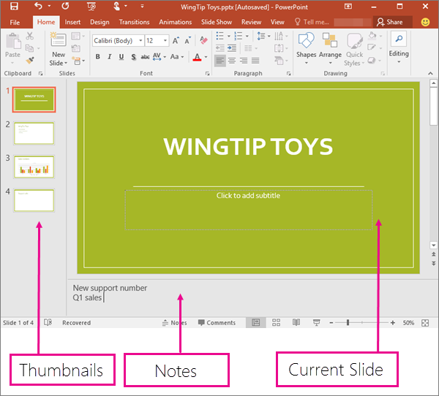

#### Slide Sorter view

You can get to **Slide Sorter** view from the task bar  at the bottom of the slide window, or from the **View** tab on the ribbon.

**Slide Sorter** view (below) displays all the slides in your presentation in horizontally sequenced, thumbnails. Slide show view is helpful if you need to reorganize your slides—you can just click and drag your slides to a new location, or add sections to organize your slides into meaningful groups.

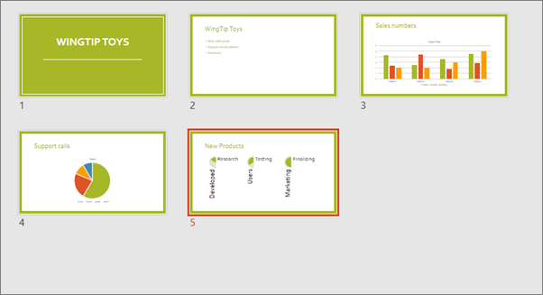

For more information about sections, see [Organize your PowerPoint slides into sections](https://support.microsoft.com/en-us/office/organize-your-powerpoint-slides-into-sections-de4bf162-e9cc-4f58-b64a-7ab09443b9f8).

#### Notes Page view

You can show or hide your speakers notes with the **Notes** button at the bottom of the slide window, or you can get to **Notes Page** view from the **View** tab on the ribbon.

The **Notes** pane is located beneath the slide window. You can print your notes or include the notes in a presentation that you send to the audience, or just use them as cues for yourself while you're presenting.

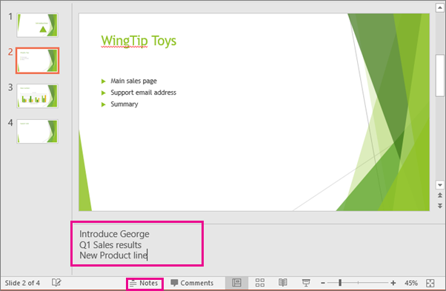

For more information about notes, see [Add speaker notes to your slides](https://support.microsoft.com/en-us/office/add-speaker-notes-to-your-slides-26985155-35f5-45ba-812b-e1bd3c48928e).

#### Outline view

You can get to **Outline** view from the **View** tab on the ribbon. (In PowerPoint 2013 and later, you can no longer get to **Outline** view from **Normal** view. You have to get to it from the **View** tab.)

Use **Outline**view to create an outline or story board for your presentation. It displays only the *text* on your slides, not pictures or other graphical items.

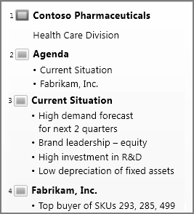

#### Master views

To get to a master view, on the **View** tab, in the **Master Views** group, choose the master view that you want.

**Master** views include, **Slide**, **Handout**, and **Notes**. The key benefit to working in a master view is that you can make universal style changes to every slide, notes page, or handout associated with your presentation.

### Views for delivering and viewing a presentation

#### Slide Show view

You can get to **SlideShow** view from the task bar at the bottom of the slide window.

Use Slide Show view to deliver your presentation to your audience. Slide Show view occupies the full computer screen, exactly the way your presentation will look on a big screen when your audience sees it.

#### Presenter view

To get to **Presenter** view, in **Slide Show** view, in the lower left corner of the screen, click The Show Presenter View button in PowerPoint., and then click **Show Presenter View** (as shown below).

Use **Presenter** view to view your notes while delivering your presentation. In **Presenter** view, your audience cannot see your notes.

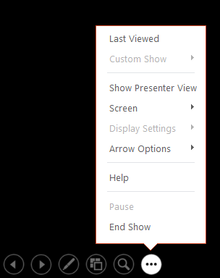

For more information about using Presenter view, see [View your speaker notes as you deliver your slide show](https://support.microsoft.com/en-us/office/start-the-presentation-and-see-your-notes-in-presenter-view-4de90e28-487e-435c-9401-eb49a3801257).

#### Reading view

You can get to **Reading** view from the task bar at the bottom of the slide window.

Most people reviewing a PowerPoint presentation without a presenter will want to use Reading view. It displays the presentation in a full screen like Slide Show view, and it includes a few simple controls to make it easy to flip through the slides.

1. What do you mean by Handouts, Note pages and Outline? How can Smart Art be used in MS PowerPoint?

Ans: A handouts is a special view of the presentation suitable to be printed and distributed to the audience.

Note pages (formerly called “comments” in earlier versions of Excel) don’t have a Reply box. Notes are just for adding annotations or reminders in cells.

Use an outline to quickly display summary rows or columns, or to reveal the detail data for each group. You can create an outline of rows (as shown in the example below), an outline of columns, or an outline of columns, or an outline of both rows and columns. Outline symbols.

### Insert Smart Art

The Smart Art feature lets you create and customize designer-quality diagrams. You can even convert bulleted lists into a diagram using the Smart Art diagram tools.

1. Click the **Insert** tab.
2. Click the **Smart Art** button on the ribbon.

You can also click the Smart Art icon in a content placeholder.

1. Select a category.
2. Select a graphic.

A preview and a description appear on the right.

1. Click **OK**.

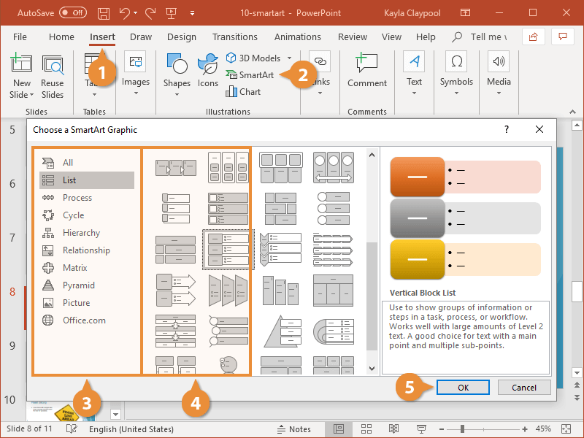

The Smart Art graphic is inserted into the presentation.

|  |  |
| --- | --- |
| **Smart Art Graphic Types** | |
| **List** | Show non-sequential information. |
| **Process** | Show steps in a process or timeline. |
| **Cycle** | Show a continual process. |
| **Hierarchy** | Create an organization chart or decision tree. |
| **Relationship** | Illustrate connections. |
| **Matrix** | Show how parts relate to a whole. |
| **Pyramid** | Show proportional relationships with the largest component on the top or bottom. |
| **Picture** | Create a SmartArt graphic that incorporates pictures. |

1. Write down the steps of recording a slideshow in MS PowerPoint.

Ans: Create a presentation

* 1. Open Power point
  2. In the left pane, select New.
  3. Select an option: To create a presentation from scratch, select Blank Presentation. To use a prepared design, select one of the templates. To see tips for using Power point, select Create.

1. Prepare a report on all the Tabs of MS Excel.

Ans: The ribbon is designed to assist in quickly finding Excel commands to complete a task. The commands are grouped together in logical groups, which are collected together under tabs.

Each tab relates to a particular activity, such as page layout or view. Some tabs only appear when needed to reduce the clutter on the screen. These tabs are known as **Contextual** Tabs.

Commands related to working with Excel workbook content are represented as buttons on the tabs that make up the groups. The **Home** tab is activated by default when Excel is opened. Within each tab, except the **File** Tab, the buttons are organized into groups. In some groups, the button that might be used most often is larger than the other buttons.

Less common commands can be accessed by clicking the **Dialog Box** or **Task Pane Launcher** button located in the lower right corner of the group about the command.

Many tabs are available on the Ribbon in Microsoft Excel, such as Home, Insert, Page Layout, Formula, Data, Review, and View, and each tab has different features.

### Home Tab

The excel Home Tab is used to execute regular instructions like bold, underline, copy, and paste. It is also used to apply formats to cells in a worksheet. It contains Clipboard, Font, Alignment, Number, Cells, and Editing.

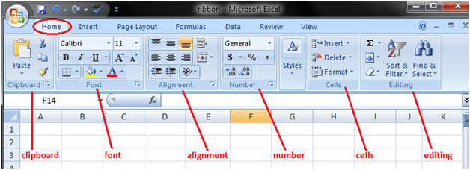

**1. Clipboard:** This Clipboard Group is primarily used for Cut copy and paste. It means, if you want to transfer data from one place to another, then you have two choices, either COPY (preserves the data in the original location) or CUT (deletes the data from the original location).

* There are options of **Paste Special**, which implies copy in the desired format.
* And there is also **Format Painter** Excel, which is used to copy the format from the original cell location to the destination cell location.

**2. Fonts:** This font group within the Home tab is used for choosing the desired Font and size. There are hundreds of fonts available in the dropdown, which we can use for.

In addition, you can change the font size from small to large, depending on your requirements. Also helpful is the feature of Bold (B), Italics (I), and Underline (U) of the fonts.

**3. Alignment:**This group is used to align tabs, such as Top, Middle, or Bottom alignment of text within the cell. And there are other standard alignment options like Left, middle, and right alignment. There is also an orientation option that can be used to place the text vertically or diagonally.

* **Merge and Center** is used to combine more than one cell and place its content in the middle. It is a great feature to use for table formatting etc.
* **Wrap text** can be used when there is a lot of content in the cell, making all the text visible.

**4. Number:** This group provides options for displaying number format. There are various formats available, such as general, accounting, percentage, comma style in excel, etc. You can also increase and decrease the decimals using this group.

**5. Styles:** You can have various styles for cells like Good, Bad, and Neutral. Other sets of styles are available for Data and Models like Calculation, Check, Warning, etc.

In addition, you can make use of different Titles and Heading options available within Styles.

* The **format Table** allows you to convert mundane data into an aesthetically pleasing data table quickly.
* **Conditional formatting** is used to format cells based on certain predefined conditions. These are very helpful in spotting the patterns across an excel sheet.

**6. Cells:** This group is used to modify the cell according to its height and width etc. Also, you can hide and protect the cell using Format Feature. You can also insert and delete new cells and rows from this group.

**7. Editing:** This group within the Home Tab is useful for Editing the data on an excel sheet. The most prominent of the commands here is the Find and Replace in Excel Also, you can use the sort feature to analyze your data (sort from A to Z or Z to A), or you can do a custom sort here.

### Insert Tab

The Insert Tab is used to insert distinct features like tables, pictures, clip art, shapes, charts, page numbers, word art, headers, and footers into a document. It contains Tables, Illustrations, Add-Ins, Charts, Tours, Sparklines, Filters, Links, Text, and Symbols groups. The below table describes each of the teams and buttons present on this tab.

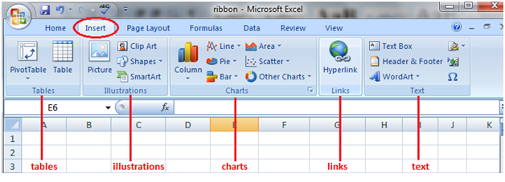

**1. Tables:** This group provides an excellent way to organize the data. You can use a table to sort, filter, and format the data within the sheet. You can also use Pivot Tables to analyze complex data very easily.

**2. Illustrations:** This group provides a way to insert pictures, shapes, or artwork into excel. You can insert the pictures directly from the computer or use Online Picture Option to search for relevant pictures.

* The **shapes** provide additional ready-made square, circle, arrow kinds of shapes that can use in excel.
* **SmartArt** provides an awesome graphical representation to visually communicate data in List, organizational charts, Venn diagrams, and process diagrams.

**3. Charts:** It helps you visualize the data in a graphical format. You can make graphs on your own, and excel provides various options like Pie-chart, Line Chart, Column Chart in Excel, Bubble Chart k in Excel, combo chart in excel, Radar Chart in Excel, and Pivot Charts in Excel. Recommended charts allow Excel to come up with the best possible graphical combination.

**4. Hyperlink:** This is a great tool to provide hyperlinks from the excel sheet to an external URL or files. Hyperlinks can also use to create a navigation structure with the excel sheet that is easy to use.

**5. Text:** This group is used to text in the desired format, such as add header and footer.

* **WordArt** allows you to use different styling for text.
* You can also create your signature using the **Signature line**
* **Symbols** are special characters that we may want to insert in the excel sheet for better representation.
* **The equation** allows you to write mathematical equations that we cannot ordinarily write in an Excel sheet.

### Page Layout Tab

The Page Layout Tab holds all the choices that permit you to rearrange your document pages simply in the manner you wish them. You can set margins, apply themes, manage page orientation and size, add sections and line breaks, show line numbers, and set paragraph indentation and lines. It contains Themes, Page Setup, Scale to fit, Sheet Options, Arrange.

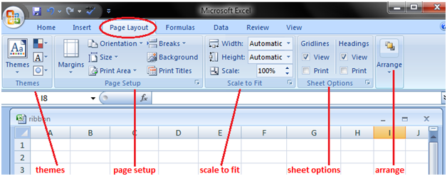

**1. Themes:** Themes allow you to change the style and visual look of excel. You can choose various styles available from the menu. You can also customize the colors, fonts, and effects in the excel workbook.

**2. Page Setup:** This is an important group primarily used along with printing an excel sheet.

* You can choose **margins** for the print.
* You can choose your printing **orientation** from Portrait to Landscape.
* You can choose the **size** of paper like A3, A4, Letterhead, etc.
* The **print area** allows you to see the print area within the excel sheet and helps make the necessary adjustments.
* We can also add a **break** where we want the next page to begin in the printed copy.
* Also, you can add a **background** to the worksheet to create a style.
* **Print Titles** is like a header and footer in excelthat we want them to be repeated on each printed copy of the excel sheet.

**3. Scale to Fit:** This option is used to stretch or shrink the printout of the page to a percentage of the original size. You can also shrink the width as well as height to fit in a certain number of pages.

**4. Sheet Options:** It is another useful feature for printing. If we want to print the grid, then we can check the print gridlines option. If we want to print the Row and column numbers in the excel sheet, we can also do the same using this feature.

**5. Arrange:** Here, we have different options for objects inserted in Excel like Bringforward, Send Backward, Selection Pane, Align, Group Objects, and Rotate.

### Formula Tab

The formula tab is used to insert functions, outline the name, produce the name, review the formula, etc. In the ribbon, the Formulas tab has vital and most helpful functions to form dynamic reports. It contains Function Library, Defined Names, Formula Auditing, and Calculation.

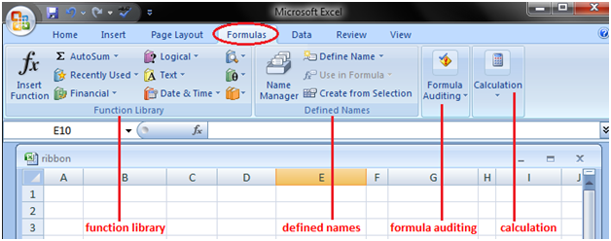

**1. Function Library:** This is a very useful group that contains all the formulas that one uses in excel. This group is subdivided into important functions like Financial Functions, Logical Functions, Date & Timing, Lookup & References, Maths and Trignometry, and other functions. One can also make use of Insert Function capabilities to insert the function in a cell.

**2. Defined Names:** This feature can be used to name the cell, and these named cells can be called from any part of the worksheet without working about its exact locations.

**3. Formula Auditing:** This is used for auditing the flow of formulas and their linkages.

* It can **trace the precedents** (origin of data set) and show which dataset depends on this.
* **Show formula** can also use to debug errors in the formula.
* The **Watch window** in excel is also useful for keeping a tab on their values as you update other formulas and datasets in the excel sheet.

**4. Calculations:** The option selected for calculation is automatic. However, one can also change this option to manual.

### Data Tab

The data tab contains options mainly for filtering, sorting, and manipulating data. It has options for importing external data.

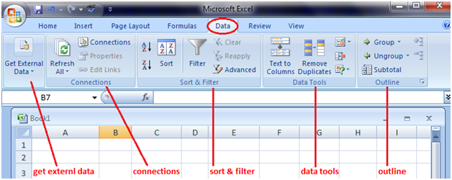

1. **Get External Data:** This option is used to import external data from various sources like Access, Web, Text, SQL Server, XML, etc.
2. **Power Query:** This is an advanced feature used to combine data from multiple sources and present it in the desired format.
3. **Connections:** This feature is used to refresh the excel sheet when the data in the current excel sheet comes from outside sources. You can also display the external links as well as edit those links from this feature.
4. **Sort & Filter:** This feature can be used to sort the data from A to Z or Z to A, and also you can filter the data using the dropdown menus. Also, one can choose advanced features to filter using complex criteria.
5. **Data Tools:** This is very useful for advanced excel users. One can create various scenario analyses using Whatif analysis - Data Tables, Goal Seek in Excel, and Scenario Manager. Also, one can convert Text to Column, remove duplicates and consolidate from this group.
6. **Forecast:** This Forecast function can be used to predict the values based on historical values.
7. **Outline:** One can easily present the data in an intuitive format using the Group and Ungroup options.

### Review Tab

The review tab contains tools mainly for spell checking, thesaurus, sharing, protecting, and tracking changes in Excel Worksheets.

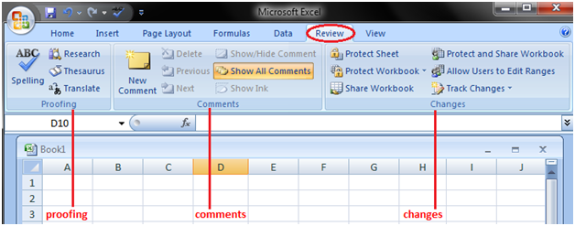

1. **Proofing:** Proofing allows you to run spell checks in excel. In addition to spell checks, one can also use a thesaurus if you find the right word. There is also a research button that helps you navigate the encyclopedia, dictionaries, etc., to perform tasks better.
2. **Language:** You can translate the excelsheet from English to any other language by using this feature.
3. **Comments: This feature is used** to write an additional note for important cells. It helps the user understand clearly the reasons behind your calculations etc.
4. **Changes:** If you want to keep track of the changes made, one can use the Track Changes option. Also, you can protect the worksheet or the workbook using a password from this option.

### View Tab

View tab contains mainly commands to view the Excel worksheet, like change views, freeze panes, arrange multiple windows, etc.

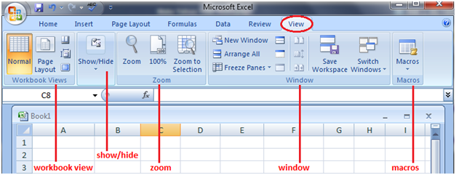

1. **Workbook Views:** You can choose the viewing option of the excel sheet from this group. You can view the excel sheet in the default normal view, or you can choose Page Break view, Page Layout view, or any other custom view of your choice.
2. **Show:** This feature can be used to show or not show Formula bars, grid lines, or Heading in the excel sheet.
3. **Zoom:** Sometimes, an excel sheet may contain a lot of data, and you may want to change zoom in or zoom out desired areas of the excel sheet.
4. **Window:** The new window is a helpful feature that allows the user to open the second window and work on both simultaneously. Also, freeze panesare another useful feature that allows freezing of particular rows and columns such that they are always visible even when one scrolls to the extreme positions. You can also split the worksheet into two parts for separate navigation.
5. **Macros:** This is again a fairly advanced feature, and you can use this feature to automate certain tasks in Excel Sheet. Macros are nothing but a recorder of actions taken in excel, and they can execute the same actions again if required.

# Quick Access Toolbar in Excel

The **Quick Access Toolbar** (QAT) is a small, customizable toolbar at the top of the Office application window that contains a set of frequently used commands. These commands can be accessed from almost any part of the application, independent of the ribbon tab that is currently opened.

The Quick Access Toolbar has a drop-down menu containing a predefined set of the default commands, which may be displayed or hidden. Additionally, it includes an option to add your own commands.

There is no limit to a maximum number of commands on the QAT, although not all the commands may be visible depending on the size of your screen.

### Where is the Quick Access Toolbar Located?

A customizable toolbar is located in the upper left corner of the Excel window, above the ribbon. If you want QAT to be closer to the worksheet area, you can move it below the ribbon.

When you click the down arrow at the end of the quick access toolbar, it displays more commands. You can add any of these commands to the quick access toolbar by a left click on the command.

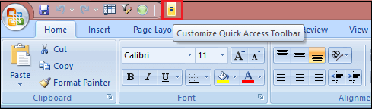

### Customized Quick Access Toolbar

By default, the Excel Quick Access Toolbar contains only three buttons: **Save, Undo,** and **Redo.** If you use a few other commands frequently, you can add them to the Quick Access Toolbar.

Microsoft provides many customization options for the QAT, but still, certain things cannot be done.

You can customize or free to personalize the Quick Access Toolbar with the following things, such as:

* Add your own commands.
* Change the order of commands, both default, and custom.
* Display the QAT in one of the two possible locations.
* Add macros to the Quick Access Toolbar.
* Export and import your customizations.

But here is a list of the following things that cannot be changed or cannot be customized, such as:

* You can only add commands to the Quick Access Toolbar. **Individual list items** (e.g., spacing values) and **individual styles** cannot be added. However, you can add the whole list or entire style gallery.
* Only command icons can be displayed, not **text labels.**
* You cannot **resize** the Quick Access Toolbar buttons. The only way to change the size of the buttons is to change your screen resolution.
* The Quick Access Toolbar cannot be displayed on **multiple lines.** If you've added more commands than the space available, some commands won't be visible. To view them, click the **More Controls** button.

### How to customize Quick Access Toolbar Window

Most customizations to the QAT are done in the Customize Quick Access Toolbar window, which is part of the **Excel Options** dialog box. You can open this window by following these steps:

**Step 1:** Click on the **File** tab and go to the **Excel Options.**

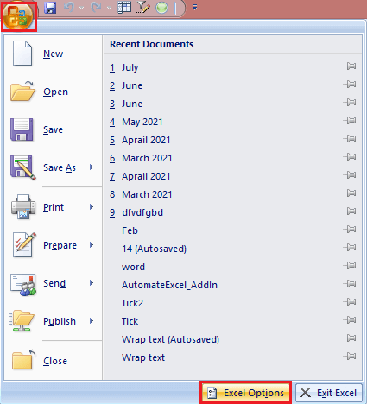

**Step 2:** Click on the customize button.

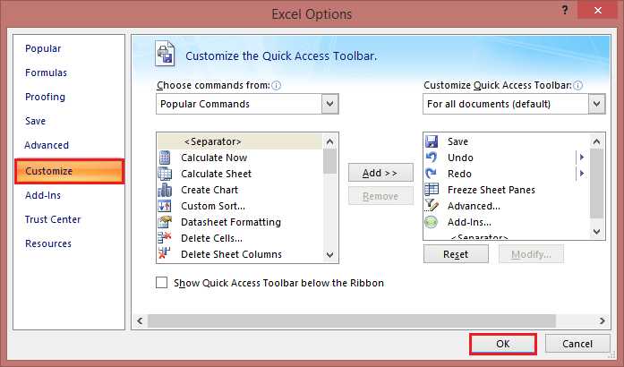

**Step 3:** The **Customize Quick Access** Toolbar dialog window will open, where you can add, remove, and reorder the QAT commands.

**Step 4:** And then click on the **OK** button.

### How to Add Command Button to Quick Access Toolbar

Depending on what kind of command you want to add, this can be done in three different ways.

1. **Enable a command from the predefined list**  
   To enable a currently hidden command from the predefined list, this is what you need to do:
   * Click the **Customize Quick Access Toolbar** button (the down arrow).
   * In the list of the displayed commands, click the one you want to enable.

For example, to be able to create a new worksheet with a mouse click, select the **New** command in the list, and the corresponding button will immediately appear in the Quick Access Toolbar:  
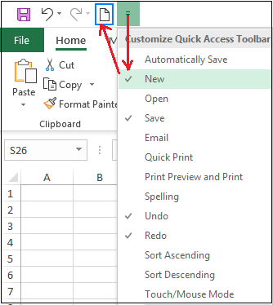

1. **Add a ribbon button to Quick Access Toolbar**  
   The fastest way to add to the QAT a command that appears on the ribbon is:
   * Right-click the desired command on the ribbon.
   * And select the **Add to Quick Access Toolbar** in the context menu.

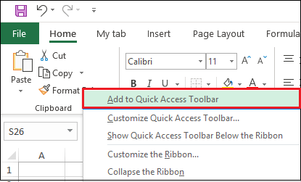

1. **Add a command that isn't on the ribbon to Quick Access Toolbar**  
   To add a button that is not available on the ribbon, follow these steps:  
   **Step 1:** Right-click on the ribbon and click **Customize Quick Access Toolbar.**  
   **Step 2:** In the **Choose commands from** the drop-down list on the left, select **Commands Not in the Ribbon.**  
   **Step 3:** In the list of commands on the left, click the command you want to add.  
   **Step 4:** Click on the **Add** button.  
   **Step 5:** Click on the **OK** to save the changes.

For example, to have **New** open Excel windows with a single mouse click, you can add the **New** button to the Quick Access Toolbar.

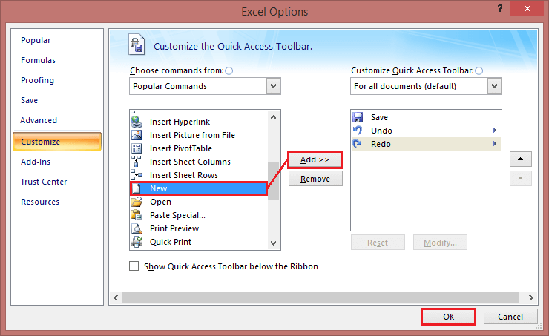

### How to Remove a Command from Quick Access Toolbar

To remove either a default or custom command from the Quick Access Toolbar, right-click it and pick **Remove from Quick Access Toolbar** from the pop-up menu.

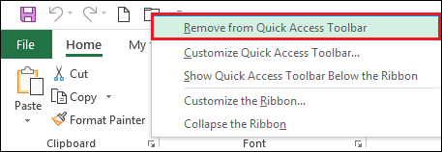

Or select the command in the **Customize the Quick Access Toolbar** window, and then click the **Remove** button.

### Rearrange Commands on Quick Access Toolbar

To change the order of the quick access toolbar commands, follow the following steps:

**Step 1:** Open the **Customize the Quick Access Toolbar** window.

**Step 2:** Under **Customize Quick Access Toolbar** on the right, select the command you want to move, and click the **Move Up or Move Down** arrow.

For example, to move the **New** File button to the far-right end of the quick access toolbar, select it and click the **Move Down** arrow.

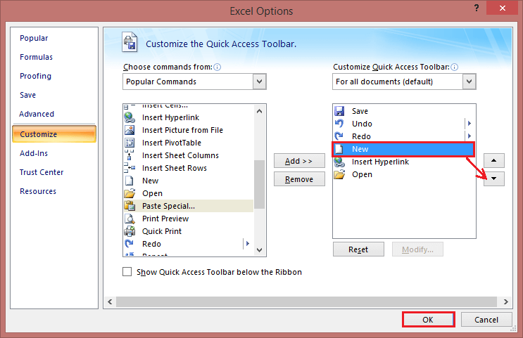

### Group Commands on Quick Access Toolbar

If your quick access toolbar contains quite a lot of commands, you may want to sub-divide them into logical groups. For example, separate the default and custom commands.

Though the Quick Access Toolbar does not allow creating groups like on the Excel ribbon, you can group commands by adding a separator. Follow the following steps, such as:

**Step 1:** Open the **Customize the Quick Access Toolbar** dialog window.

**Step 2:** In the **Choose commands from** the drop-down list on the left, pick **Popular Commands.**

**Step 3:** In the list of commands on the left, select and click **Add.**

**Step 4:** Click the **Move Up** or **Move Down** arrow to position the separator where needed.

**Step 5:** Click **OK** to save the changes.

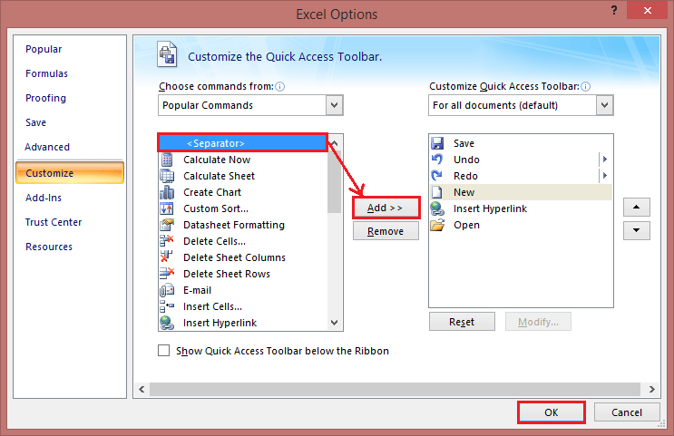

As a result, it separates the command, and the quick access toolbar appears to have two sections, as shown in the below image:

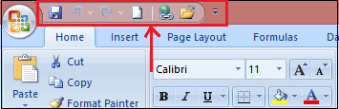

## Add Macros to Quick Access Toolbar

To have your favorite macros at your fingertips, you can add them to the QAT too. To have it done, then follow these steps:

**Step 1:** Open the **Customize the Quick Access Toolbar** window.

**Step 2:** In the **Choose commands from** the drop-down list on the left, select **Macros.**

**Step 3:** In the list of macros, select the one you wish to add to the Quick Access Toolbar.

**Step 4:** Click on the **Add** button.

**Step 5:** Click on the **OK** to save the changes and close the dialog box.

As an example, we are adding a custom macro **RANDOM** in the current workbook:

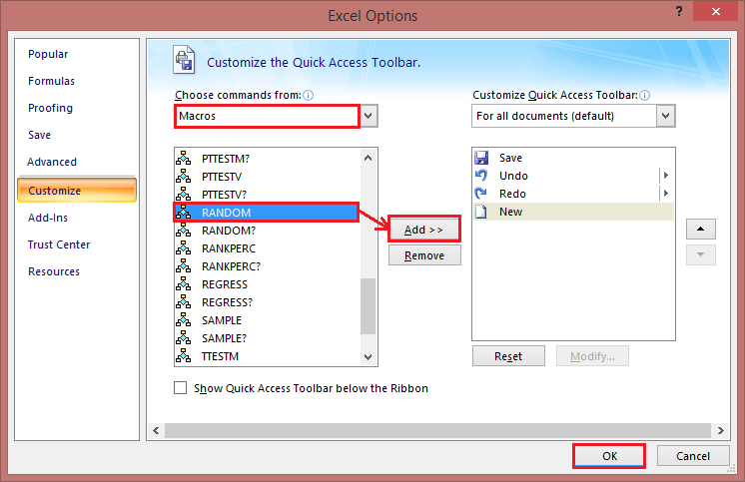

Optionally, you can put a separator before the macro like shown in the screenshot below:

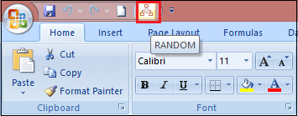

### Export and Import a Custom Quick Access Toolbar

Microsoft Excel allows saving your Quick Access Toolbar and ribbon customizations into a file that can be imported later. This can help you keep your Excel interface looking the same on all the computers you use and share your customizations with your colleagues.

1. **Export** a customized quick access toolbar:  
   In the Customize the Quick Access Toolbar window, click **Import/Export,** then click **Export all customizations,** and save the customizations file to some folder.
2. **Import** a customized quick access toolbar:  
   In the Customize the Quick Access Toolbar window, click **Import/Export,** select **Import customization file,** and browse for the customizations file you saved earlier.

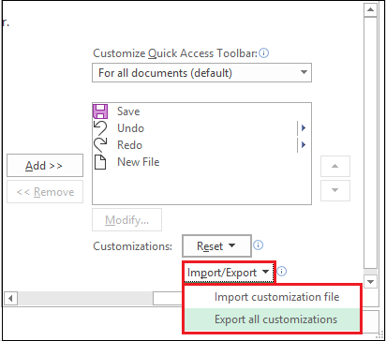

The file that you export and import also includes the **ribbon customizations.** Unfortunately, there is no easy way to export or import, only the Quick Access Toolbar.

When you import the customizations file to a given PC, all prior ribbon and **QAT** customizations on that PC are permanently lost. To restore your current customizations in the future, be sure to export them and save them as a backup copy before importing any new customizations.

# Mini Toolbar in Excel

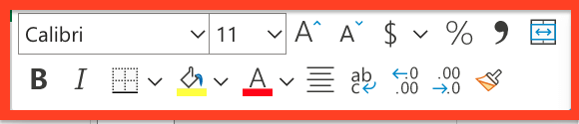

**The Mini Toolbar is a floating toolbar that appears above the shortcut menu when you right-click a cell or other objects like a shape or chart**. It is a small version of the full toolbar that displays commonly used formatting commands like **Bold, Italics, Font Size** and **Font Color**. The mini toolbar was introduced as a quick-access version so the Excel users can easily access the Font group, border, and few extra buttons on the Home tab.

The Mini Toolbar is also available in other office applications such as Word and PowerPoint. When you select any text or right-click on it, a faded, partially transparent pop window emerges on the top of your selected text. If you hover your mouse pointer over it, it immediately converts to its solid and usable form. Sometimes the Excel users may find it annoying as it keeps getting in the way. In that case, they can turn it off (we will learn the steps to turn off Mini Toolbar later in this tutorial).

**FACT:** Do you know that the Mini Toolbar feature is only available in the 2007 and 2010 versions of [Word](https://www.javatpoint.com/ms-word-tutorial), [Excel](https://www.javatpoint.com/excel-tutorial), [PowerPoint](https://www.javatpoint.com/powerpoint-tutorial), and [Outlook](https://www.javatpoint.com/outlook-app-for-android-mobile). The user can even turn off this feature if it is not required. However, the toolbar commands are pre-defined and cannot be customized to include different other functions.

### Mini Toolbar Mouse Pointer Rules:

* If you bring your mouse pointer towards the Mini Toolbar, it freezes and immediately becomes active.
* If you take your mouse pointer away from the Mini Toolbar, it disappears.
* You will notice that the Mini Toolbar disappears if you press any key from your keyboard or scroll the wheel of your mouse.

## Mini Toolbar Features:

The mini toolbar contains the most commonly used tools of the Home Tab. The list of the tools are as follows:

**1. Font Type**(Drop-Down) - The Font feature shows the list of fonts available in Excel. The user can quickly select or change the font of the cell as per their choices.

**2. Font Size**(Drop-Down). With the help of Font Size, you can quickly adjust the size of the text.

**3. Increase Font Size**- This feature allows Excel users to quickly increase the font size of the selected cell to the next larger font size.

**4. Decrease Font Size**- This feature allows the Excel users to quickly decrease the font size of the selected cell to the previous smaller font size.

**5. Percent Style**- With the help of the Percent Style feature, you can incorporate the percent number format into the selected cells.

#### NOTE: The shortcut key to perform percent style in Excel is Ctrl + Shift + %.

**6. Comma Style**- With the help of the Percent Style feature, you can incorporate the comma style number format into the selected cells.

**7. Accounting Number Format**(Drop-Down)- The Accounting Number feature incorporates the '**default**' number format to the selected cells. The drop-down consists of the following commands:

* English (UK)
* English (US)
* Euro
* and More Accounting Formats.

**8. Merge & Center**(Drop-Down). The Merger & Centre feature concatenates the selected cells and puts the contents in a new cell in the centre position. The drop-down consists of the following commands:

* Merge & Center
* Merge Across
* Merge Cells and Unmerge Cells

The Merge Across is similar to the Merge and Center feature with a single difference that merges and centres the selected cells in the same row with no change in the alignment.

**9. Bold**- This feature toggles bold on the selected cell.

#### NOTE: The shortcut key to apply Bold in Excel is Ctrl + B.

**10. Italic**- This feature toggles italics on the selected cell.

#### NOTE: The shortcut key to apply Bold in Excel is Ctrl + I.

**11. Center**- This feature aligns the content of the selected cell in the center position.

**12. Fill Color**(Drop-Down)- The Fill Color feature is useful whenever the user want to quickly apply a color to the background of the selected cell. The drop-down consists of the following commands:

* Theme Colors
* Standard Colors
* No Fill and More Colors.

**13. Font Color** (Drop-Down). As the name suggests, the Font colour features allow the Excel user to quickly change the colour of the font of the selected cell. The Font Color drop-down incorporates the below give commands:

* Automatic
* Theme Colors
* Standard Colors and More Colors.

**14. Borders**(Drop-Down). The Borders enables the users to quickly apply a border of any length and thickness to the selected cells. The Borders drop-down incorporates the below give commands:

* Bottom
* Top
* Left
* Right
* No
* All
* Outside
* Thick Box
* Top and Bottom
* Draw Border
* Thick Bottom
* Top and Thick Bottom
* Erase Border
* Bottom Double
* Top and Double Bottom
* Draw Border Grid
* Line Color
* Line Style and More Borders.

**15. Increase Decimal**- As the name suggest, this features adds one decimal place from the selected cells.

**16. Decrease Decimal**- As the name suggests, Increase Decimal adds one decimal place from the selected cells.

**17. Format Painter**- This feature copies the formatting from any cell (or group of cells or range) enabling the user to paste the same formatting elsewhere.

### Removing the Mini Toolbar

Many times, while working on excel, the Mini Toolbar pops up very often, and therefore many users may find it annoying as it keeps getting in the way. Thus, Excel provides the option to switch off Mini Toolbar. Following are the steps to turn off the Mini Toolbar from Excel:

1. In your Excel application, **click on File > Options > General**.
2. You will see the check box in front of the Show Mini Toolbar. **Clear the selection**. (Refer to the below screenshot)  
   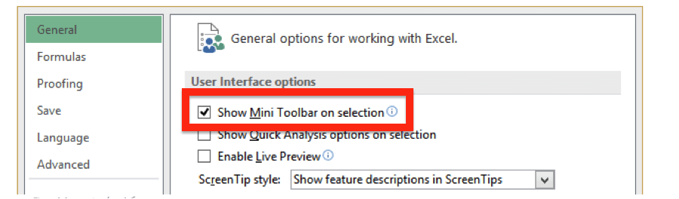
3. Click **OK**.

# Title Bar, Help Button, Zoom Control and View Buttons

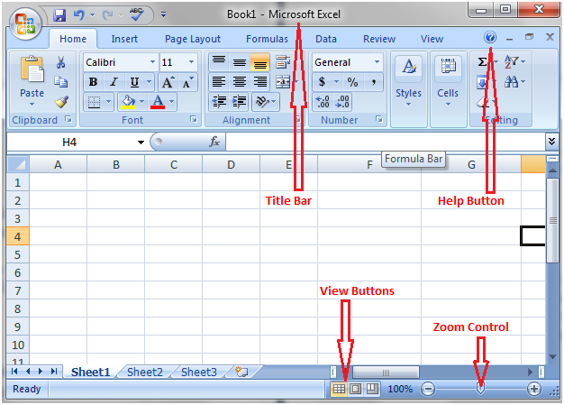

### Title Bar

It lies next to the quick access toolbar or on top of the excel window. It displays the name of the open document.

### Help Button

It lies on top right corner of the excel window beside the option to minimize the window. It is in the form of an encircled question mark. It provides excel related help.

### Zoom Control

Zoom control is a slider that lies next to view buttons at the right end of the status bar. It helps zoom in and zoom out the document. Move the slider to right or click on the plus sign to zoom in and move it to left or click on the minus sign to zoom out.

### View Buttons

There are three view buttons on the right end of the status bar, to the left of the zoom control. These buttons provide different options to view the document.

# Worksheets in Excel

While working with Excel, often you come across terms worksheet, Rows, Columns and Cells. In this tutorial we will briefly understand these terms along with their fundamentals and the operation (create, copy, paste, delete, etc) performed in them.

## Worksheet

A Worksheet is a single page **containing a collection of cells** where the user can store, update and manipulate the data. Worksheet is also called a spreadsheet. It is made up of **rows, columns and cells**.

#### NOTE: An Excel workbook can contain several worksheets.

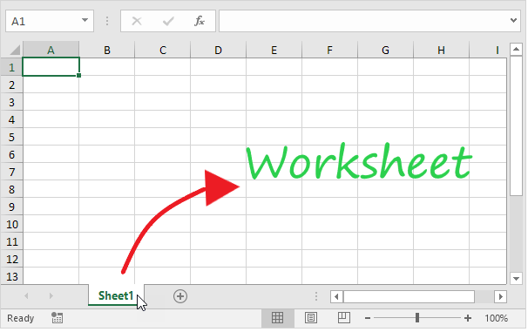

In Excel, individual data cells in a worksheet are defined and organized with the help of the vertical column and horizontal row that are combined to form a cell reference, unlike A1, B25, or R867.

The specifications for Excel Worksheet current versions include:

* Number of Rows per Worksheet: **1,048,576**
* Number of Rows per Worksheet: **16,384**
* Total cells per Worksheet: **17,179,869,184**

## Select a Worksheet

Whenever you open an **Excel** workbook, by default, Excel will take you to the Sheet1 worksheet. As you can see in the below image, the name of the worksheet 'Sheet1' is displayed on its sheet tab at the bottom of the windowpane. Though you can **rename it anytime**, we will cover the steps down in this tutorial.

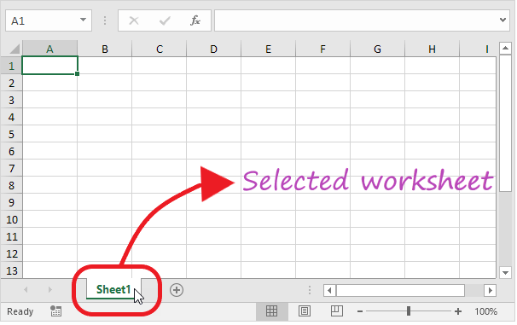

### Insert a Worksheet

Excel enables the user to insert multiple worksheets as per their requirement. To **insert a new worksheet** in excel, click on the plus (+) symbol located at the bottom of the windowpane. By default, the new worksheet will be named 'SheetN' where N represents an integer number 1,2,3,4,5,6,7,...., n.

In the below example, we have added a new worksheet named Sheet2.

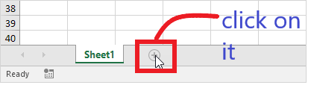

**Output**

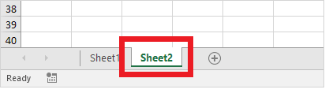

### Rename a Worksheet

To rename your worksheet with a customized and appropriate name following the below steps.

1. Right-click on the sheet tab for which you wish to change the name.
2. The toolbar window will appear. Choose the **Rename** option.  
   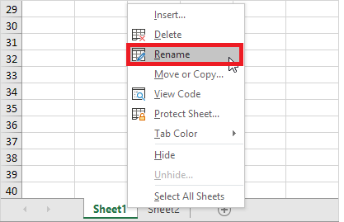
3. Type your preferred name. For instance, in the below screenshot, we have renamed 'Sheet1' to Sales 2021.  
   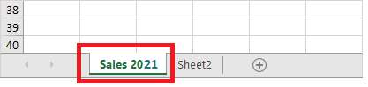

### Move a Worksheet

Excel allows the user to move and locate their worksheet in any order. Click on your worksheet sheet tab and **drag it to your preferred location**.

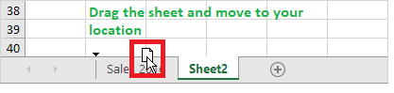

For instance, in the below example, we have dragged Sales 2021 before the 'Sheet 2' sheet tab.

**Output**

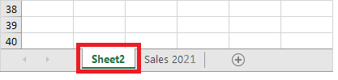

Delete a Worksheet

Deleting a worksheet in excel is very simple, follow the below steps:

1. Scroll down to the bottom and right click on a sheet tab.  
   
2. The dialog box will appear. Click on **delete**  
   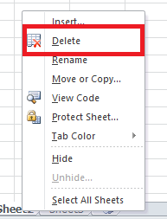
3. The sheet will be **immediately deleted**.

### Copy a Worksheet

While working many times, the Excel users require copying and pasting the data of one worksheet to another and making some changes. Excel provides easy steps to copy the data of one worksheet to another.

1. Right-click on the sheet tab that you want to copy.
2. The toolbar window will appear. Click on the 'Move or Copy' option.  
   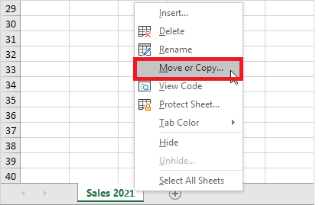
3. The 'Move or Copy' dialog box will be displayed. In the Before Sheet section, select the '**move to end'** option and make sure to check in the 'create a copy'.  
   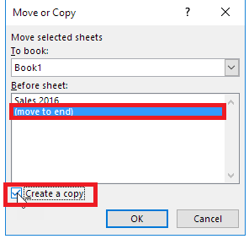
4. Click **OK**. Your data will be **copied** to the new worksheet.

## ROWS

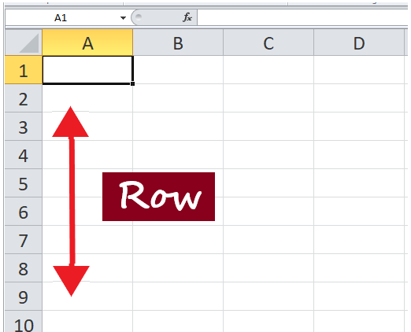

Rows run horizontally across the worksheet ranging from **1 to 1048576**. A row is **identified by the number on the left side** of the row, from where the row originates.

### Insert a Row in Excel

Many Excel users often need to insert a row in the worksheet to organize or manipulate their data.

1. Select and right-click on the cell within the row where you want to insert a new row.  
   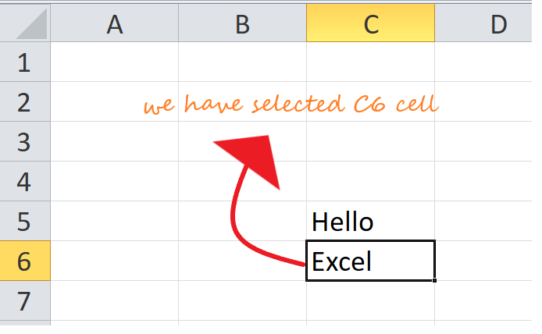
2. The dialog box will be displayed. Choose **Insert**.  
   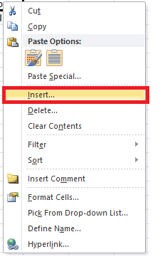
3. The insert dialog box will appear. Choose the '**Entire row'**  
   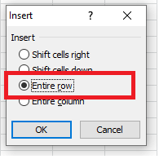
4. It will **insert a new row** at the top of your selected cell.  
   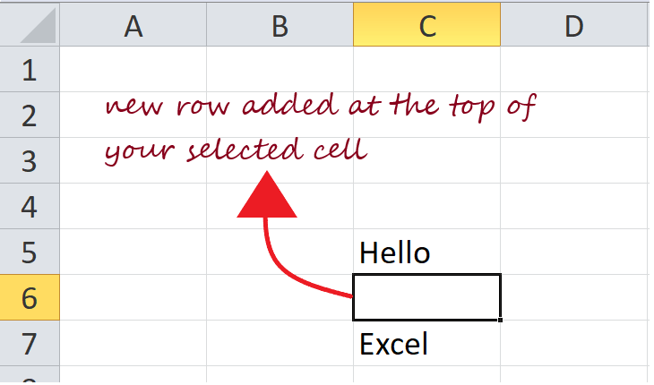

### Delete a Row in Excel

While working with Excel users need to delete a row in the worksheet to organize or manipulate their data. It's a lot easier to delete a row in excel.

1. **Select any cell** within the row that you need to **delete**. Right-click on the cell.  
   
2. The dialog box will be displayed. Choose **Delete**.  
   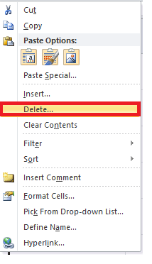
3. The **Delete** dialog box will appear. Choose the '**entire row**' option.  
   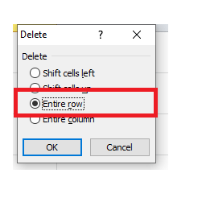
4. The entire row will be immediately deleted.  
   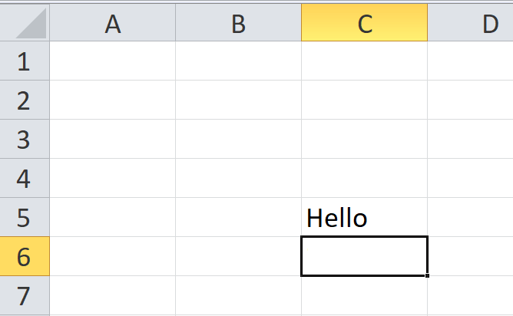

## COLUMNS

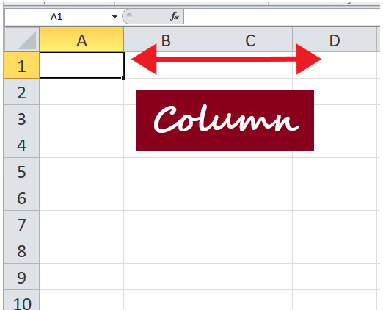

Columns run vertically downward across the worksheet ranging from **A to XFD (in total 16384 columns)**. A column is identified by a column header on the top of the column, from where the column originates.

### Insert a Column in Excel

Many Excel users often need to insert a column in the worksheet to organize or manipulate their data.

1. Select and right-click on the cell within the column where you want to **insert** a new column.  
   
2. The dialog box will be displayed. Choose **Insert**.  
   
3. The insert dialog box will appear. Choose the '**Entire column'**  
   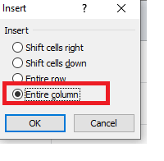
4. It will **insert a new column** at the left of your selected cell.  
   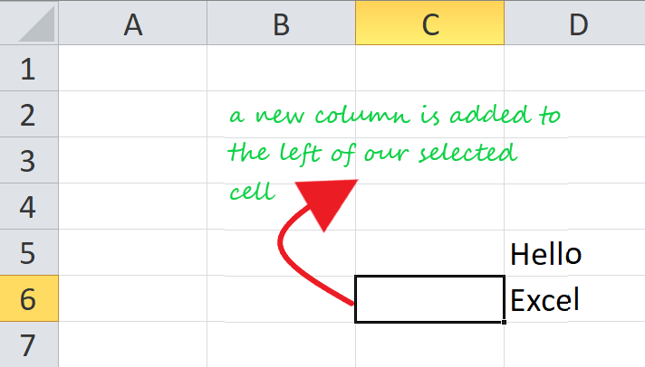

## CELLS

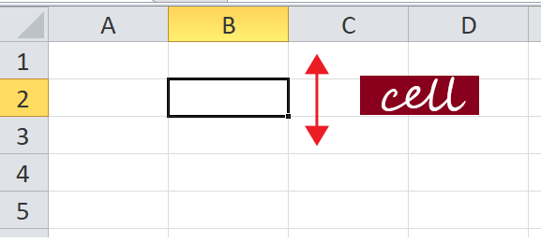

Cells are small **rectangular boxes in the worksheet where we enter data**. A cell is the intersection of a row and column. It is identified by row number and column header. In Excel, each cell is identified using a set of coordinates or positions, such as A1 (where A represents a column and 1 represents the row), B2, or M16.

You can perform several operations with cells in Excel, unlike changing the font style, font size, background color, text alignment, format painter, wrap text, and conditional formatting.

Excel provides the feature to select **multiple cells** at one time. A group of selected cells is collectively known as **cell range**. With cell range instead of a single cell address, the user refers to a cell range utilizing the cell addresses of the selected **first** and **last** cells, separated by a **colon**. For instance, a cell range covering B2, B3, B4, B5, B6, B7, B8, B9, and B10 would be addressed as **B1:B10**.

Cell Range: **B1: B10**

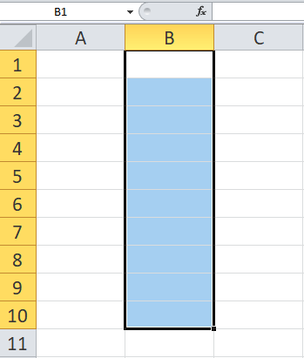

#### Now, as we have covered the basics, let's move towards the operation that could be applied to a cell.

### Select a cell

To perform any operation, i.e., to write, edit, delete, format, the user must first select a cell. Below given are the steps to select a cell in Excel:

1. With the help of your cursor, click on any cell.
2. Your cell is now selected, and you will notice a **rectangular border**around the same cell, and **the column and the row heading will be highlighted**.  
   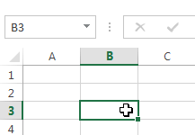
3. The **cell will remain selected**unless and until the user **points the cursor to another cell**.

### Select cell range

1. Click on the **first cell** from which to start the selection. **Hold and drag your cursor** to the last adjoining cells where you want to end the cell range.
2. Once done, **release the cursor**, and the desired cell range would be **selected**.  
   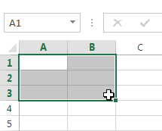
3. The cell will remain **selected**unless and until the user **points the cursor to another cell**.

### Cell content

Any data you enter in your Excel worksheet is stored in a cell. Each cell can hold various types of information, including string, numbers, formatting, formulas, and functions.

**1. String (Text)**

Cells can hold string values, unlike alphabets, numbers, and dates.

**2. Formatting properties**

Cells also include formatting properties that improve the appearance of your cell content. For instance, percentages can be displayed as 0.55 or 55%. You can make the cell content in Bold, Italics, change its font color, font size, or change its background color.

**3. Formulas and functions**

Cells can include predefined or customized formulas and functions that are helpful in calculations. For example, **SUM(A2:A5)** will add the number stored in each cell and give you the output.

### Insert content to a cell

1. Click and **select the cell**where you want to insert the content.  
   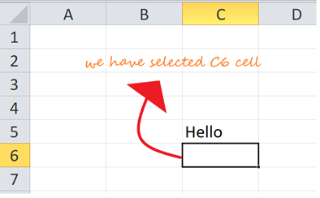
2. **Type in** the desired data into the selected cell, then **click the enter button or move your cursor to another cell**. The content will be shown in the cell and the formula bar.  
   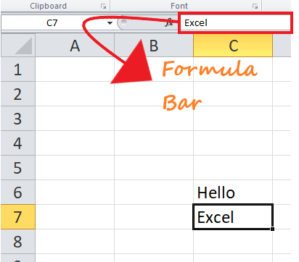

### Delete cell content

1. Click and **select** the cell.  
   
2. To delete the cell content, press the **Delete or Backspace key** from your keyboard.  
   
3. If you want to **delete multiple cells**, select the cell range and press the **Delete key**.  
   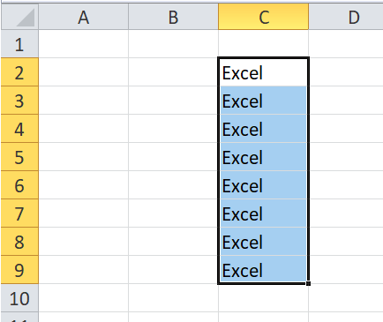

#### Note: Delete Key can delete the content of multiple cells at once, whereas the Backspace key only deletes the data of a single cell at a time.

### Delete cell(s)

People often get confused between deleting the cell content and deleting the cell itself, but there is a significant difference. If you delete the content, the cell will remain, and only the content gets omitted, whereas if you delete the cell, the cells below shift up or are shifted left and replace the deleted cell.

1. Click and select the cell(s).  
   
2. **Right-click** on the cell. The dialog box will be displayed. **Choose Delete**.  
   
3. The given below **Delete** dialog box will occur. Choose the 'entire row' option.  
   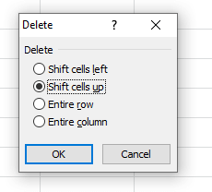
4. The cell will be immediately deleted and the cells lying below will **shift up**.  
   

## Drag and drop cells

Instead of copying and pasting the data, you can use the **drag and drop** option to move cell content from one cell to another.

1. Click and select the cell(s).
2. Point your cursor over the **border** of the selected cell(s) till it changes to a **black cross with four arrows**.Worksheet, Rows, Columns and Cells in Excel  
   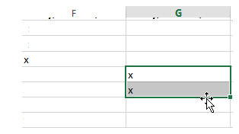
3. Drag your mouse cursor to the cell you prefer to paste the content. At this point the mouse pointer will change to a **dotted rectangle**.  
   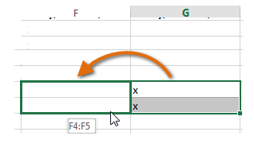
4. **Release the cursor**, and the content will be cut from the original cell and **pasted** in the selected location.  
   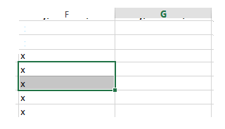

# Moving across the worksheet in Excel

There are multiple options to move across the worksheet using mouse and keyboard.

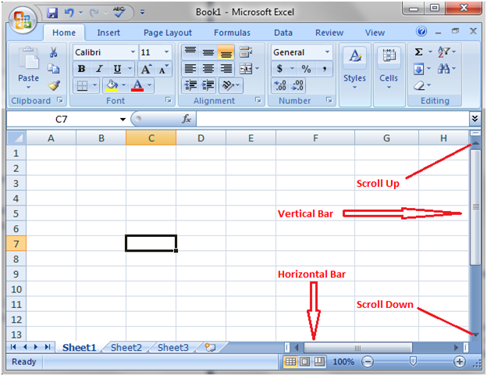

You can scroll the work sheet up or down by rolling mouse wheel or using vertical scroll bar. In a similar way, you can use horizontal scroll bar to move the work sheet horizontally towards left or right side.

# How to enter data in Excel

Select a cell with a single click where you want to enter data; cell B3 is selected in the image given below. Then double click in the cell to enter data. You can enter text, numbers and formulas in the cell.

After entering data, you can press Tab key to move to next column and can press Enter key to move to next row. You can press arrow keys for more options to move to other cells.

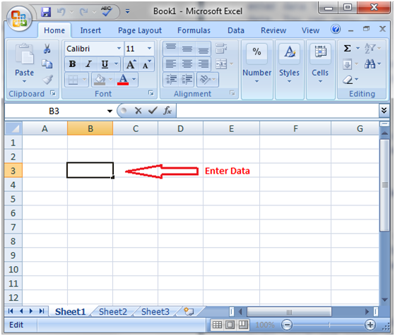

# How to select data in Excel

Selecting data is one of the most common operation Excel user practices in their day-to-day life.

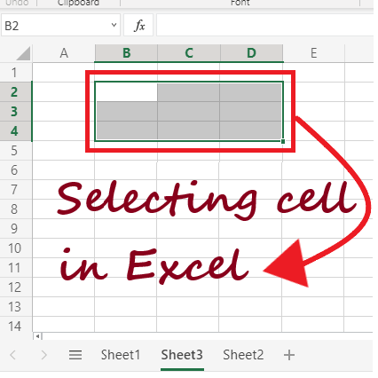

There are various methods to select a cell or multiple cells in Excel, such as through a **mouse or by keyboard shortcut keys or a combination of both**. As Microsoft Excel users, it is essential to quickly select cells, rows, columns, table cells present in an Excel worksheet. Selection assists the users in various tasks such as insertion, deletion, and formatting of multiple rows and columns in an Excel worksheet. Whenever you select any cells, row, column, or cell range, you will notice that the **color of the selected cell(s) will change** and get highlighted compared to the rest of the cells.

This tutorial will discover the various ways for selecting cells, row columns, tables, and the range of an Excel worksheet.

## Select a Single Cell

Selecting a cell in Excel is pretty easy. Just put **your mouse cursor on the respective cell** that you want to select, and that's it.

**For example:**

We want to **select the B 4 cell**. So we will keep our cursor to that particular cell address to select it.

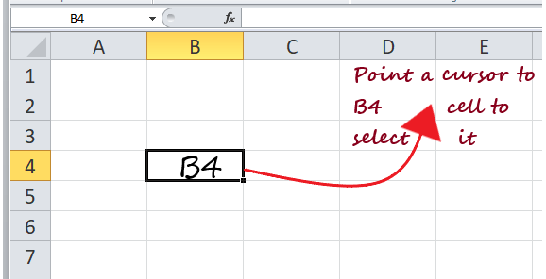

## Select Multiple Continuous Cells

Selecting multiple continuous cells is easy and simple. **Select the first cell** from where you want to start the selection **and drag the cursor to the end** of the selected cell. Suppose you want to select multiple cells **B1: E10**.

Follow the below steps:

1. Put your mouse **cursor on the first cell** from where you want to start your selection, i.e., **B1**.  
   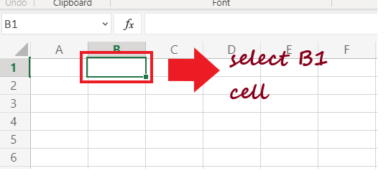
2. Press your mouse button and **drag the mouse cursor till cell E10**. It will include all the in-between cells.
3. Leave the mouse cursor, and the cells **B1: E10 will get selected**.  
   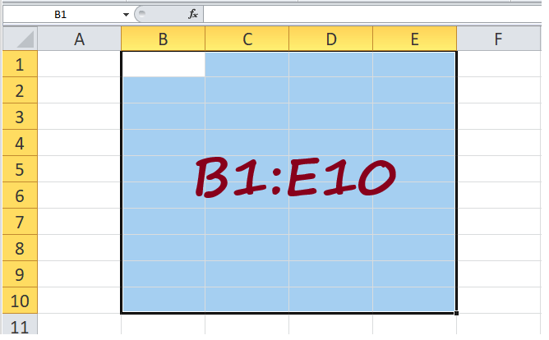

## Select Rows/Columns

While working with Excel many times, the user requires selecting an entire row or column for various operations such as hiding or deleting the row or column, applying some conditional formatting, highlighting the data, etc.

Unlike you select a cell in Excel by placing the mouse cursor on the respective cells, you can also select any row or a column by moving your mouse on the row or column.

**1. Select a Single Row**

Below given are the steps to select an entire row in Excel.

* Place your mouse **cursor on the top of your row number**. For example, if you can second the select row, so **bring** your **cursor to Row 2**.  
  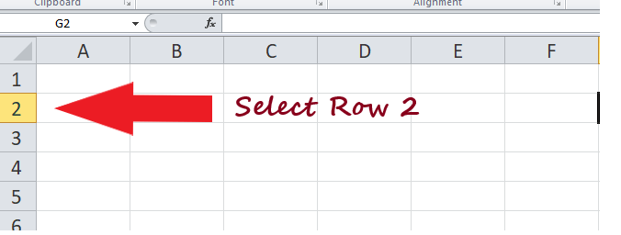
* Double **click on the row number**, and it will **select the entire row**. In the below image, you can see the entire Row 2 is selected (Excel highlights the cells in blue to represent selection).  
  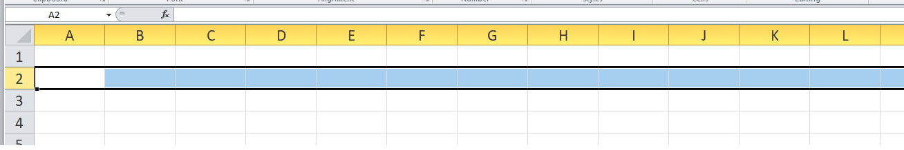

**2. Select a Single Column**

As in the above steps, we have seen how to select an entire row in Excel. Similarly, you can **select a column** as well. Follow the below steps to select an entire Column in Excel:

* Place your **mouse cursor on the top of your Column alphabet**. For example, if you can second the select column, so bring your **cursor to Column B**.  
  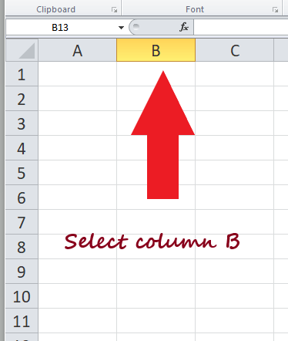
* Double **click on the column** alphabet, and it will **select the entire column**. In the below image, you can see the entire **Column B is selected**.  
  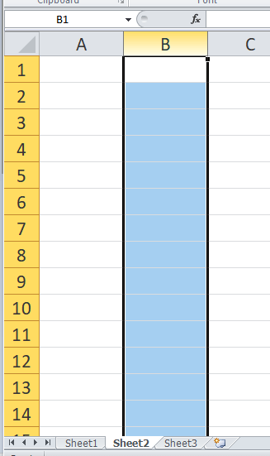

**3. Select Multiple Contiguous Rows/Columns**

We work on Excel and manipulate the data. Sometimes we want to **select multiple rows/ columns** together to apply the same operation on adjacent rows/columns at once.

For example, suppose that you want to select **row numbers 5, 6, and 7** together.

Follow the below steps.

* **Bring** your mouse **cursor over row number 5** in the Excel worksheet.  
  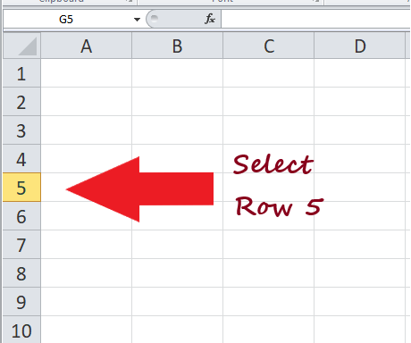
* Double **click the left cursor to select Row 5**, but **keep the mouse left button pressed** as we have to select multiple rows.  
  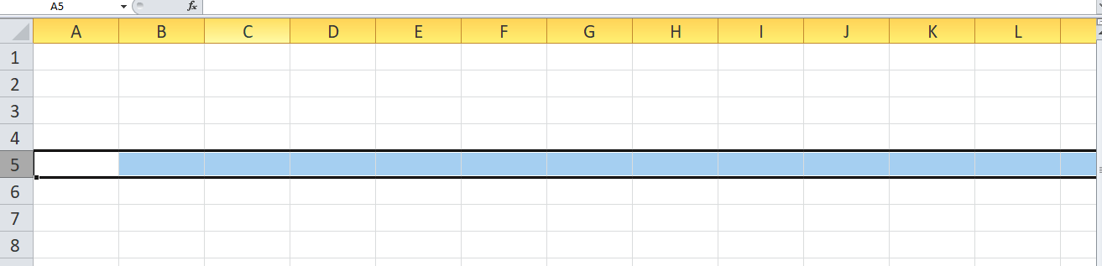
* While pressing the mouse **drag your cursor down till you reach Row 4**. At this point leave the mouse pointer and the three adjacent rows will be selected.  
  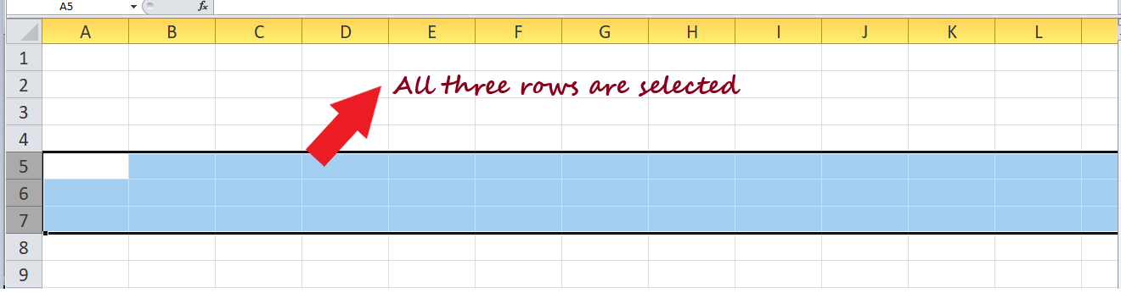

Following the above steps, you can select multiple columns as well. Make sure to click on the column alphabet instead of row number and drag till the last column selection.

**4. Select Multiple Non-Adjacent Rows/Columns**

Not always, we work with contiguous Rows/Columns. We may require it to work with **non-adjacent rows/columns** as well. How do we select them?

Selecting non-adjacent rows/columns is simple. However, the above select and drag technique won't work as restricted to adjacent cells, rows, or columns. To select random cells, rows, or columns in Excel, we have to **use a keyboard and mouse combination**. Let's say we want to select random rows such as row numbers 5, 7, 9, 10.

Below given are the steps.

1. **Bring** your **mouse cursor on the top of your first-row number**, i.e., row 5 in Excel. **Click** on the **row number** to select it.  
   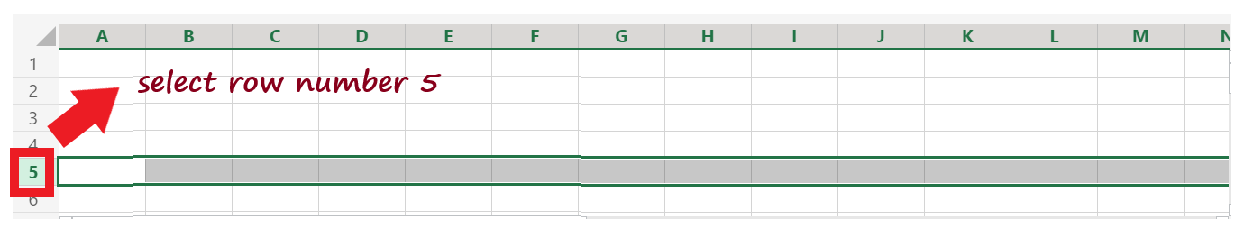
2. Next, press the **Control key** on your keyboard.  
   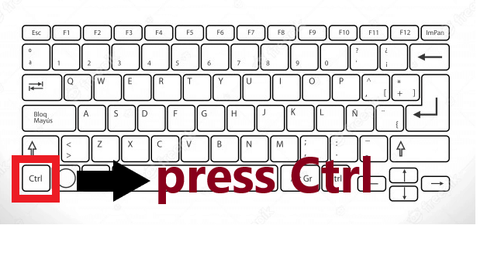
3. While pressing the Control Key, **drag your mouse cursor** to the desired row numbers to select them. First, we dragged it to **Row 7** and clicked on row number. As you can see, it got selected.  
   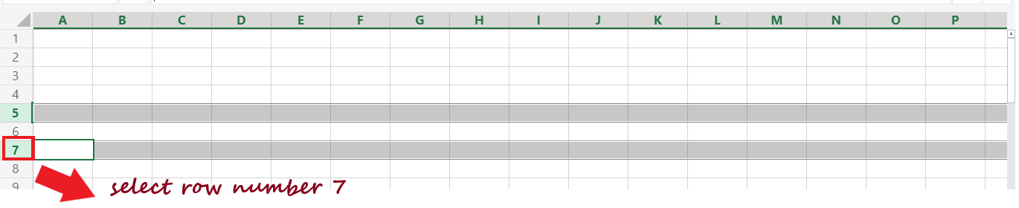
4. Leave the mouse button, **move your mouse cursor to Row 9**, click on the row number, and select it.  
   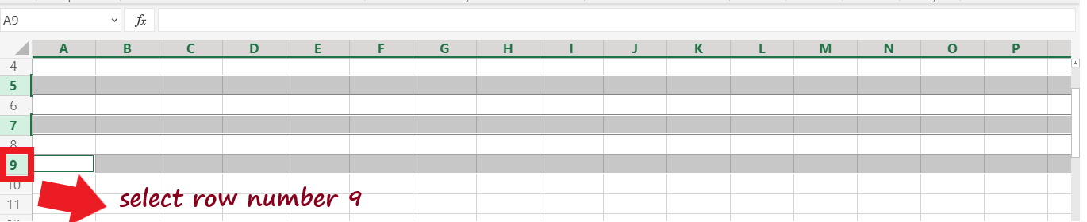
5. Similarly, **select row 11**.  
   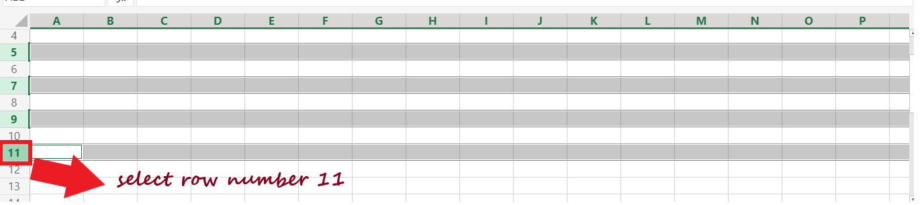
6. Once you have selected the required rows, leave the mouse and the CTRL-key.

Unlike when you have selected the adjacent rows using a keyboard and mouse combination, you can apply the same method to select multiple non-adjacent columns.

## Select the Cells in the Excel Table

Most of the time, you work with Excel Table, and you are required to select all the cells in the table to apply specific operations, formatting, or filters.

You manually select the table cell using the click and drag option. But it could be time-consuming, and with large tables, it becomes damn hard. However, with the help of Excel keyboard shortcuts, selecting the table cells of the worksheet can be done in a blink of time.

Below given are the steps.

1. Go to your table and **select any cell within your Excel table** data set  
   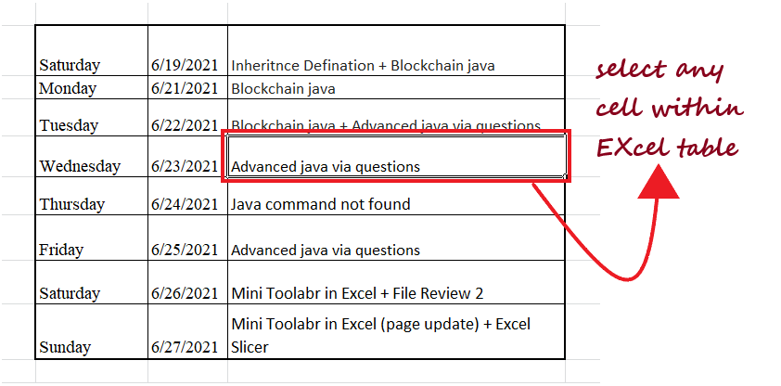
2. Press the **Ctrl key** and alphabet **A**key from your keyboard.  
   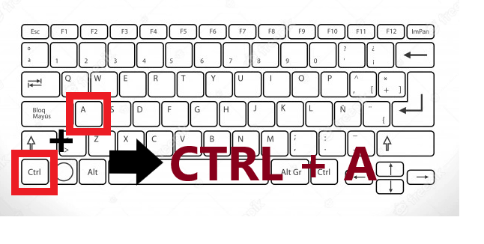
3. It will quickly **select all your cells** from the table.  
   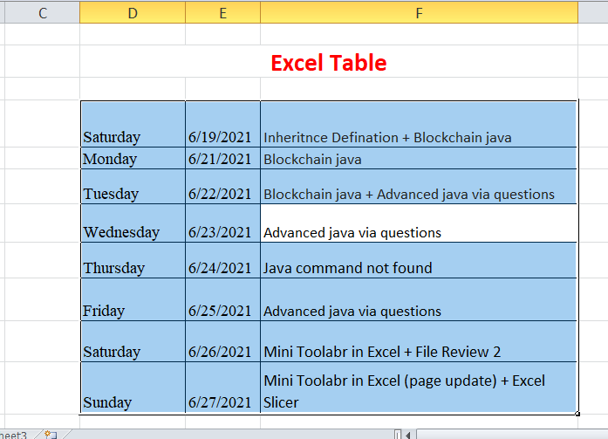

#### Note: CTRL + A would select all the cells within the table data set unless and until Excel runs into a blank row or column as it would consider the blank row or blank column as the end of the data set and won't stop the selecting operation.

## Select Cells Using Name Box

So far, we have covered various selection methods such as selecting the cells manually or with the help of keyboard shortcuts or using a combination of a mouse and keyboard. But the cells we selected were close by and easy to locate.

In some cases, you may require to select multiple continuous or non-continuous cells, rows, or columns located at a distance in your Excel worksheet. Of course, those cells can be selected manually, but to your surprise, it will be time-consuming, and if it is something you have to do regularly, then it is a great concern. Therefore, to save your time and select the far-off cells quickly, you can use the **Name Box**.

"**In Excel, Name Box is the small rectangular field placed on the top left corner of your worksheet.**"

In general, whenever you select any cell in your Excel worksheet, **the cell reference (of the active cell) is shown in the name box**. Though the vice versa is also applicable, i.e., whenever you **type any cell address in the name box, it selects** all the mentioned cells or cell range."

**For example:** Let's suppose we have to **select** multiple non-contiguous cells, unlike **B12, N43,** and **Z50**. If you notice the cells mentioned earlier are far off each other, it would be cumbersome and time-consuming if we select it manually.

So let's try selecting the cells using the name box instead. Follow the below steps.

1. With the help cursor, **click on the name box** mounted at the top left corner of your Excel worksheet.  
   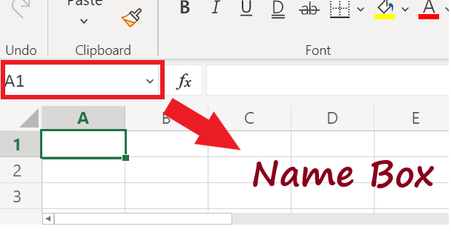
2. **Types in the cell address** that you want to select. Separate the cell references with a comma in case you want to select multiple cells. For example, in our case, we will **type in B12, N43, Z50**.  
   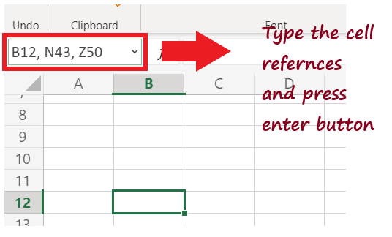
3. Once done, **press the Enter button**. It will instantly **select the entered cells**.  
   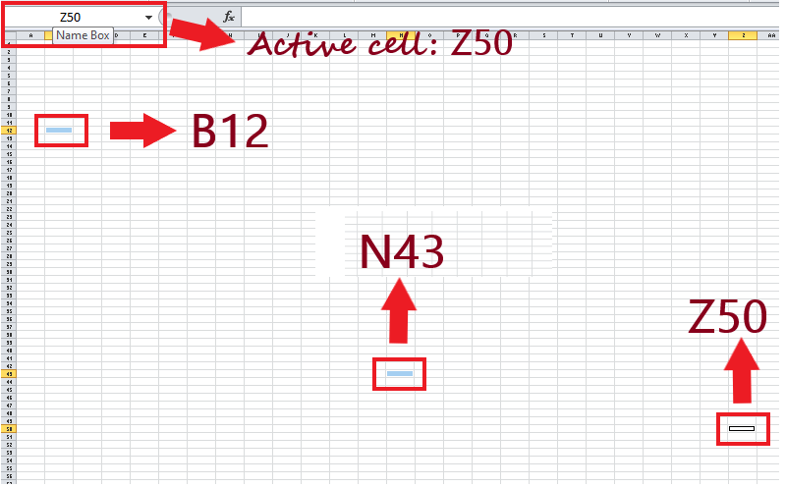

#### .

8. Create a slide using different graphs, charts, art objects, animations, animations with sounds. Add audio, video in slides. Play with display timing, slide notes and comments, background, themes, and linking and embedding objects. [SKIP]